
QUALITY ALERT

Customer: HPAC – EZPVC - Amerilux Date: June 23, 2022
Die: 15191 / 15192 / 15238 Colour: ALL
Type of Complaint: Customer Complaint

Q.A # Q.I.R # CUSTOMER NCR #

Description: Customer COMPLAINT the last panel do NOT change the side – to AVOID the damage
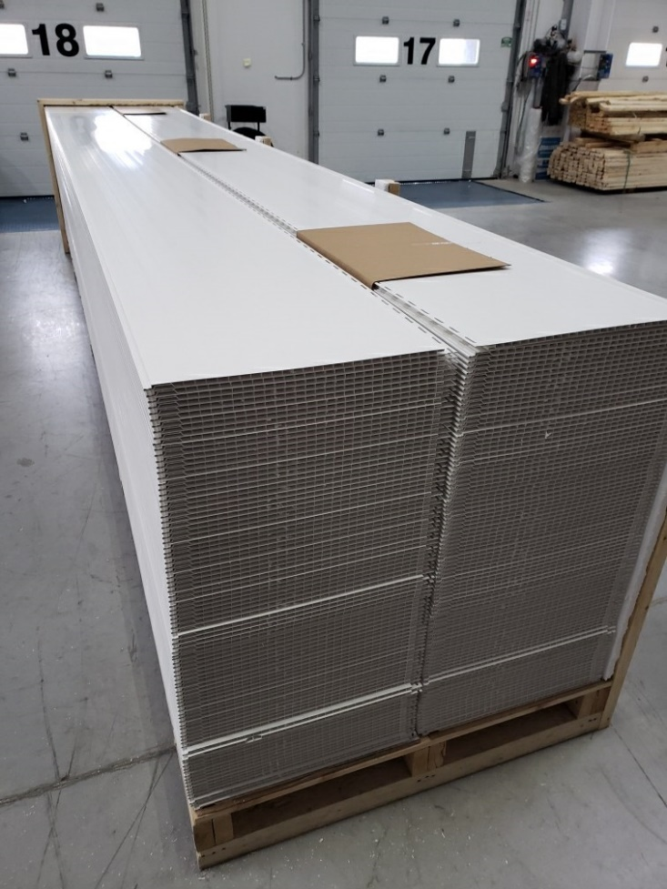
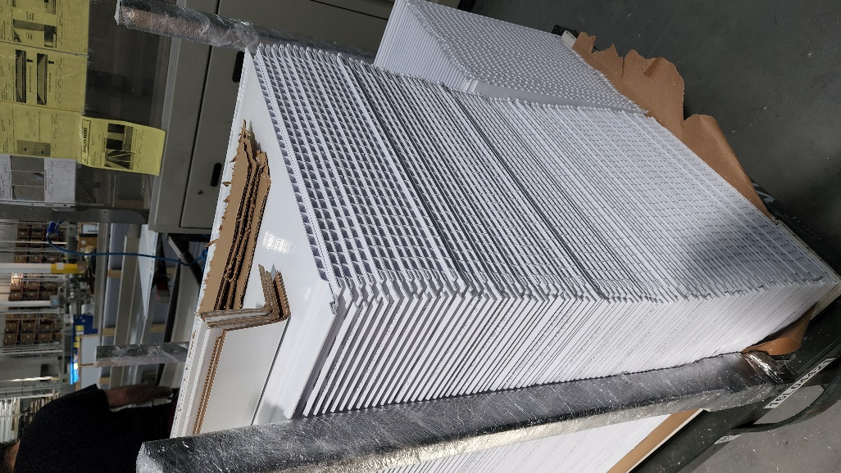
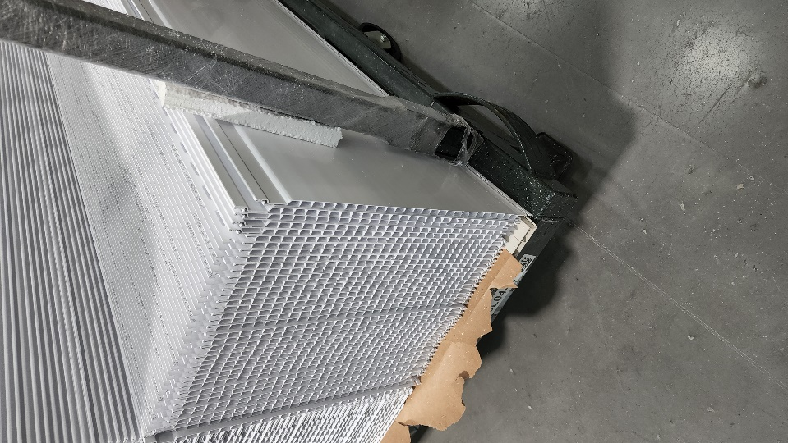
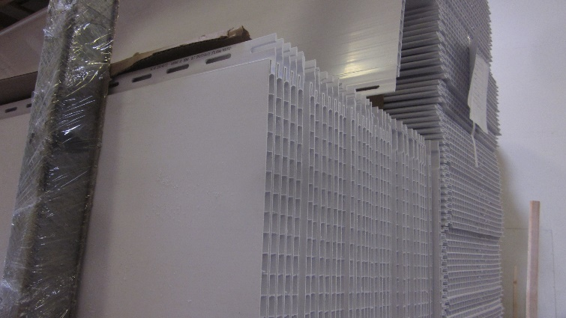

WRONG WAY

TOP/SIDE Piece to be flipped upside down to avoid damage to exposed surface
BY SIGNING BELOW, YOU ACKNOWLEDGE THE PROBLEM ABOVE AND AGREE TO MONITOR THIS ISSUE IN FUTURE PRODUCTION RUNS.
DAY SHIFT |  | AFTERNOON SHIFT |  | NIGHT SHIFT
NAME | SIGNATURE | NAME | SIGNATURE | NAME | SIGNATURE

